UML Diagrams

Video games sales Analysis

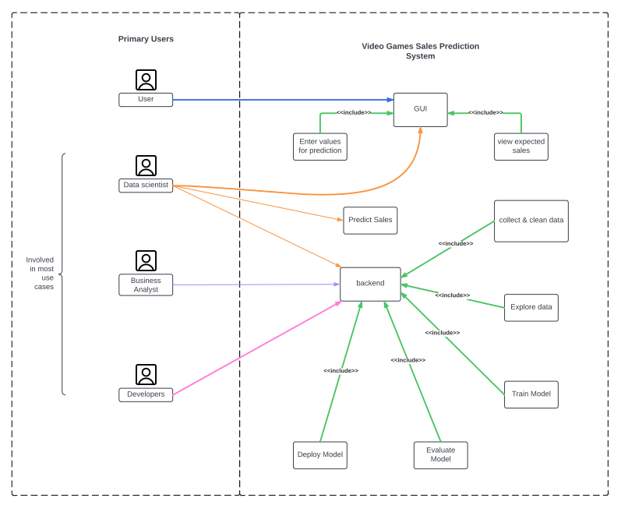UseCase

SSD

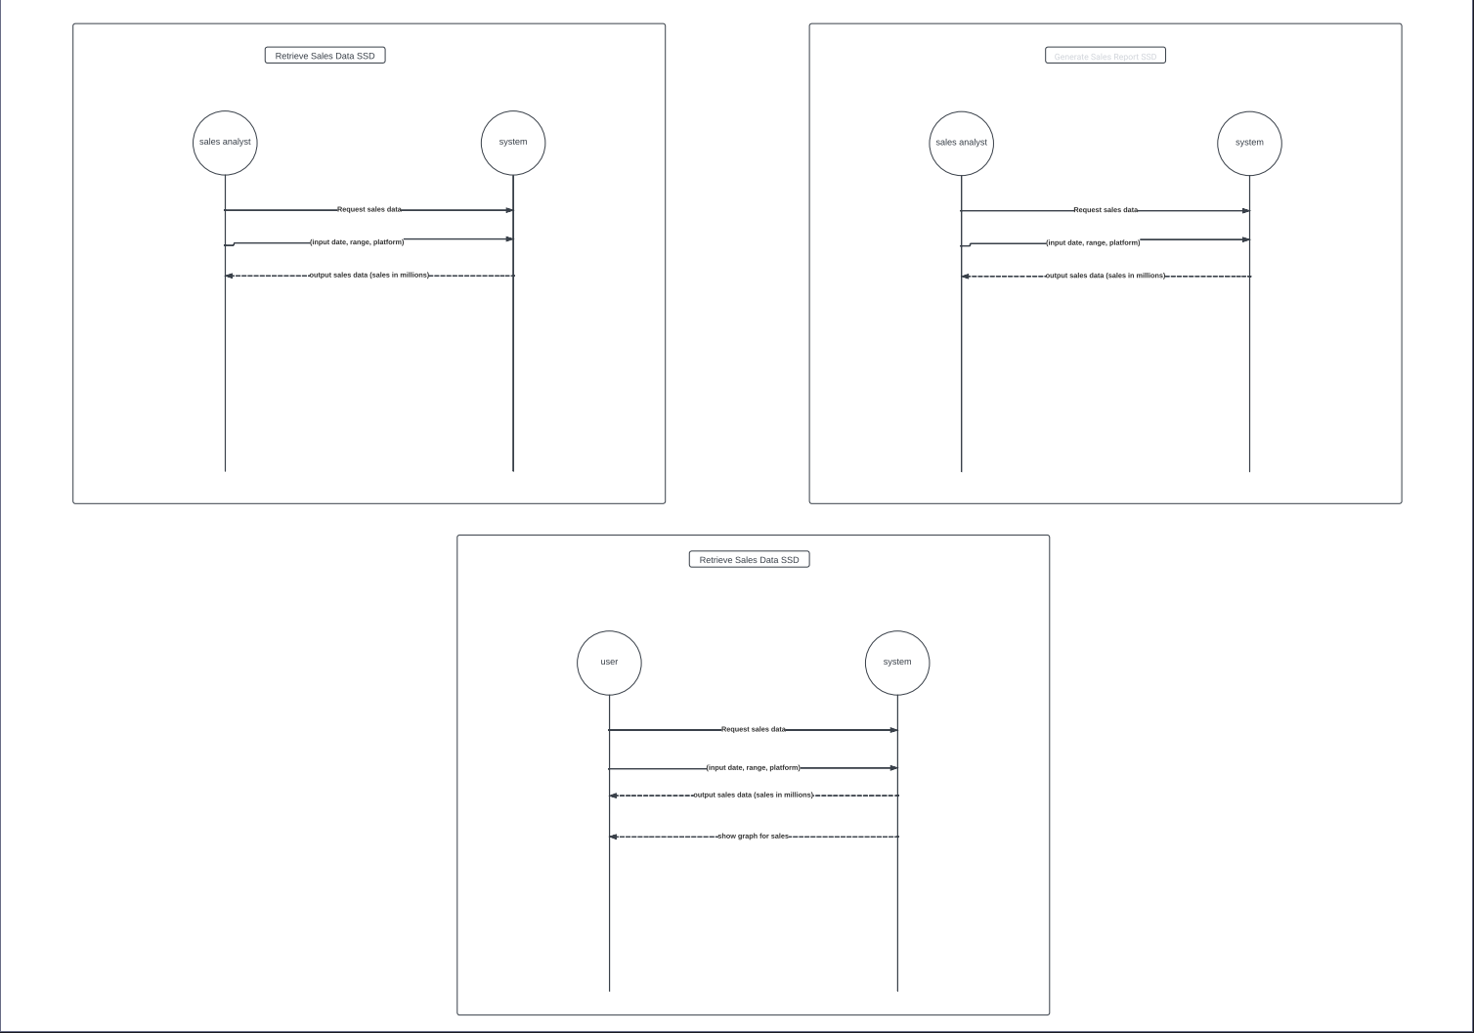

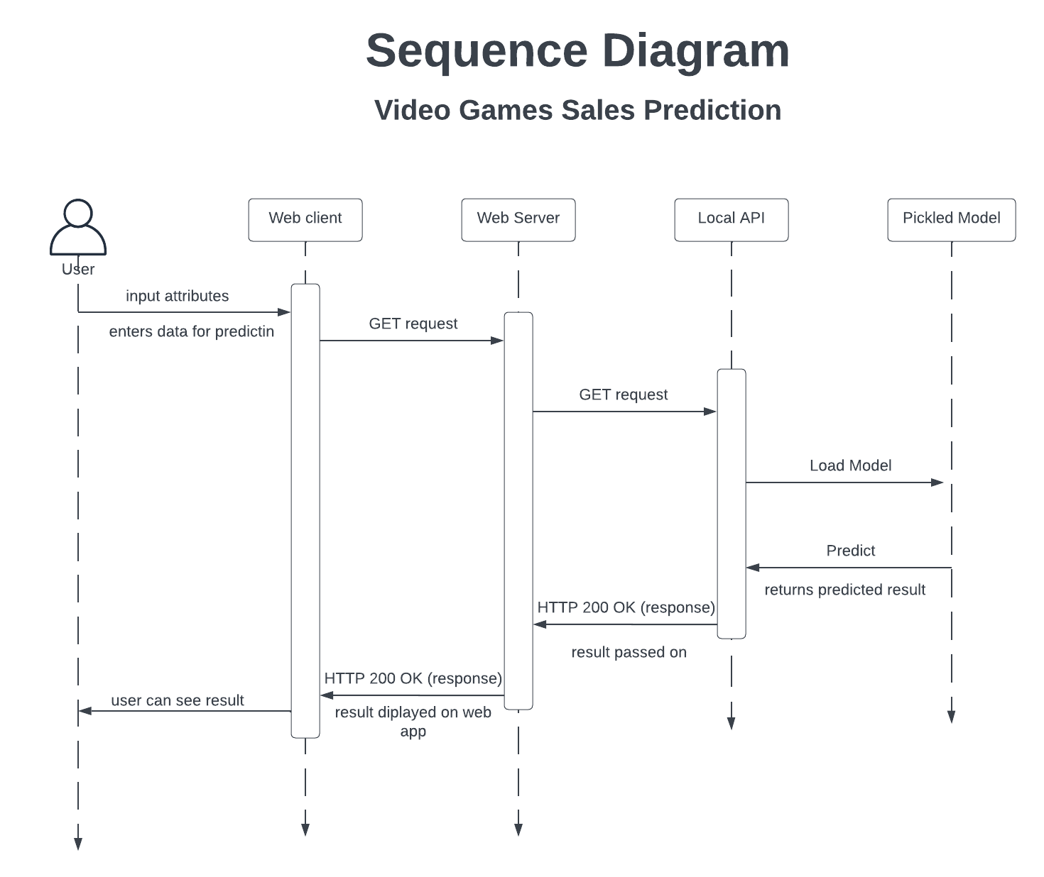

In this sequence diagram, the Web Client sends a GET request to the Web Server, which then sends a GET request to the Local API. The Local API loads the pickled machine learning model and makes a prediction. The predicted result is then returned to the Web Server, which in turn sends a HTTP 200 OK response to the Web Client. Finally, the predicted result is displayed to the user via the web application.

